SUBMITTED BY-

* NAME REGESTRATION NO ROLLNO
* RAM RAYALU 12113684 35

CSE310 :

-

JAVA

* SAI SREENIVAS 12109469 10
* RAJ SHAKER 12116318 22

SUBMITTING TO:- SHRUTI



IMAGE EDITOR

* An image editor is a software tool used to manipulate digital images. Image editors are designed to make it easy to edit, enhance, and modify digital images, often with the goal of improving their overall appearance or creating new visual compositions. Some common image editing tasks include adjusting brightness, contrast, colour, and saturation, as well as cropping, resizing, and adding various effects and filters.

INTRODUCTION

~~1.Cr~~e~~a~~t~~iv~~e e~~xp~~re~~ss~~io~~n:~~ ~~I~~mage editin~~g~~ software ~~a~~llow~~s~~ us~~er~~s to ~~e~~xpe~~ri~~ment w~~it~~h different visual stylesand create u~~n~~iq~~ue~~ ~~c~~om~~p~~ositions that express their creativity.

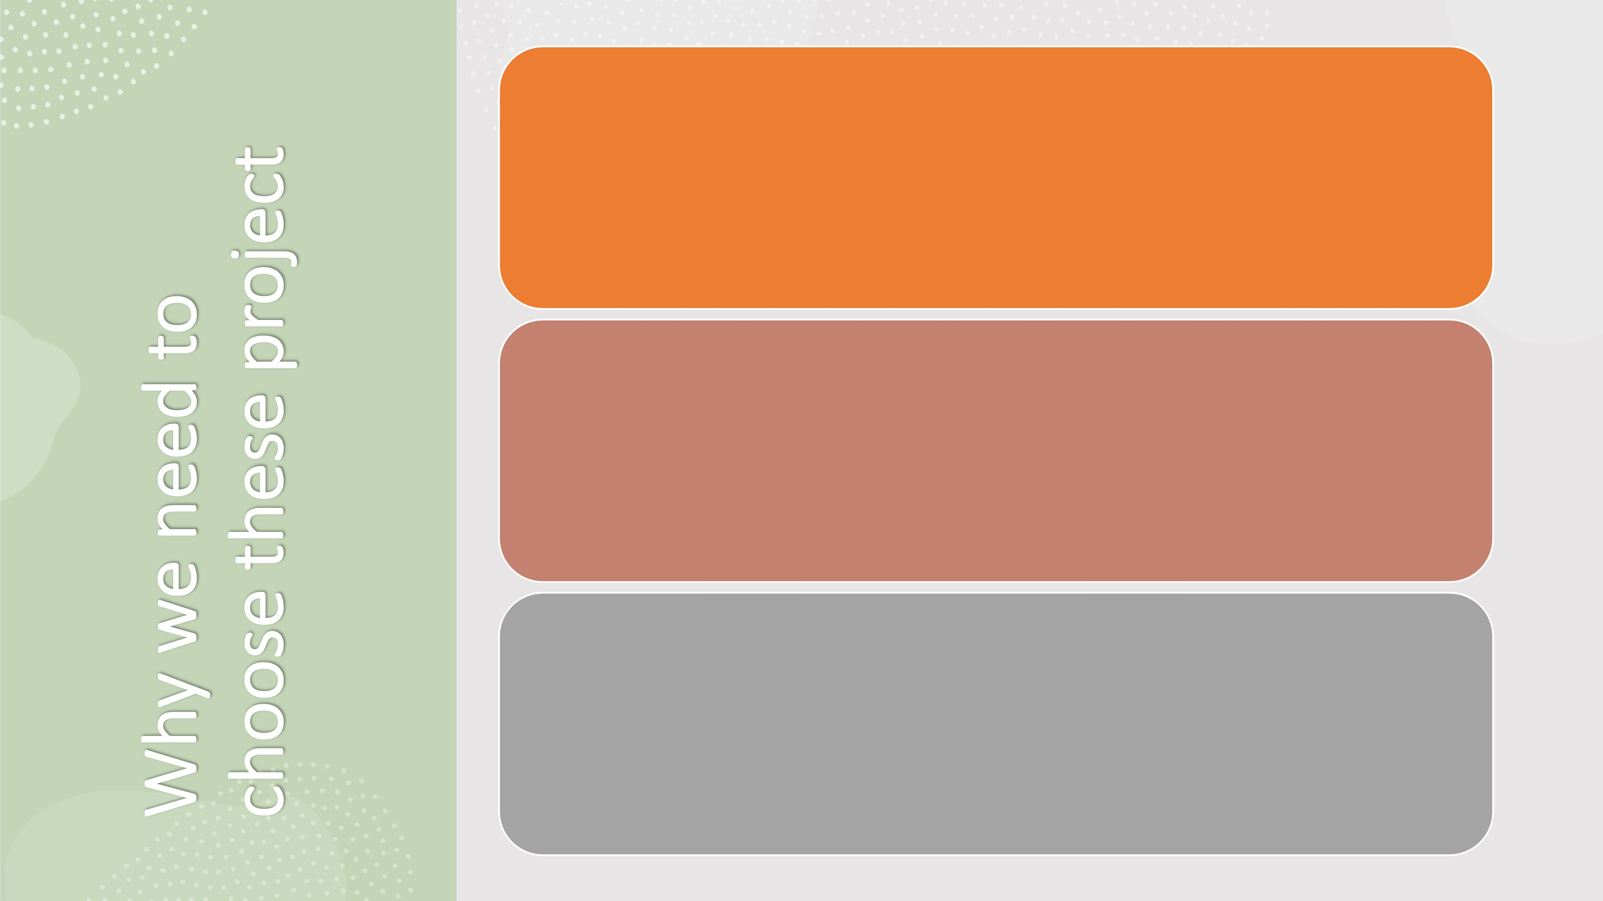2.Professional development: Learning how to use an image editor can be a valuable skill for graphic designers, photographers, and other professionals who work with digital images.

3.Personal use: People may want to use an image editor for personal reasons, such as editing family photos, creating social media posts, or designing custom invitations or cards.

# ADVANTAGES

|  |  |  |  |  |
| --- | --- | --- | --- | --- |
| 1  Image enhancement: Image editors allow users to enhance and improve the quality of their digital images by adjusting brightness, contrast, colour, and other factors. |  | 2  Creative control: Image editors give users complete creative control over their images, allowing them to manipulate and transform them in countless ways to achieve their desired results. |  | 3  Versatility: Image editors can be used for a wide range of purposes, from simple photo editing to complex graphic design and illustration. |

**DISADVANTAGES**

|  |  |  |  |  |
| --- | --- | --- | --- | --- |
| 1  File size: Large image files can take up a lot of storage space on computers, which can be a disadvantage for those with limited storage capacity. |  | 2  Misuse: Image editing software can be misused to alter images in unethical or misleading ways, such as in fake news or propaganda. |  | 3  Cost: Some image editing software can be expensive to purchase, especially for professional-grade software |

*//package com.memorynotfound.image;*

import javax.imageio.ImageIO;

import java.awt.*;

import javax.swing.*;

import java.awt.image.BufferedImage;

import java.io.File;

import java.io.IOException;

import java.awt.event.ActionEvent;

import java.awt.event.ActionListener;

class ResizeImageExample {

static void blur(String path)

throws IOException, InterruptedException {

Color color[];

File fin = new File(path);

BufferedImage input = ImageIO.read(fin);

BufferedImage output = new BufferedImage(

input.getWidth(), input.getHeight(),

BufferedImage.TYPE_INT_RGB);

int i = 0;

int max = 400, rad = 10;

int a1 = 0, r1 = 0, g1 = 0, b1 = 0;

color = new Color[max];

int x = 1, y = 1, x1, y1, ex = 5, d = 0;

for (x = rad; x < input.getHeight() - rad; x++) {

for (y = rad; y < input.getWidth() - rad; y++) {

for (x1 = x - rad; x1 < x + rad; x1++) {

for (y1 = y - rad; y1 < y + rad; y1++) {

color[i++] = new Color(

input.getRGB(y1, x1));

}

}

i = 0;

for (d = 0; d < max; d++) {

a1 = a1 + color[d].getAlpha();

}

a1 = a1 / (max);

for (d = 0; d < max; d++) {

r1 = r1 + color[d].getRed();

}

r1 = r1 / (max);

for (d = 0; d < max; d++) {

g1 = g1 + color[d].getGreen();

}

g1 = g1 / (max);

for (d = 0; d < max; d++) {

b1 = b1 + color[d].getBlue();

}

b1 = b1 / (max);

int sum1 = (a1 << 24) + (r1 << 16)

+ (g1 << 8) + b1;

output.setRGB(y, x, (int) (sum1));

}

}

ImageIO.write(

output, "jpg",

new File(path));

System.out.println("Image blurred successfully !");

}

*// Java program to demonstrate*

*// colored to grayscale conversion*

static void color(String path)

throws IOException {

BufferedImage img = null;

File f = null;

*// read image*

try {

f = new File(path);

img = ImageIO.read(f);

} catch (IOException e) {

System.out.println(e);

}

*// get image's width and height*

int width = img.getWidth();

int height = img.getHeight();

*// convert to grayscale*

for (int y = 0; y < height; y++) {

for (int x = 0; x < width; x++) {

*// Here (x,y)denotes the coordinate of image*

*// for modifying the pixel value.*

int p = img.getRGB(x, y);

int a = (p >> 24) & 0xff;

int r = (p >> 16) & 0xff;

int g = (p >> 8) & 0xff;

int b = p & 0xff;

*// calculate average*

int avg = (r + g + b) / 3;

*// replace RGB value with avg*

p = (a << 24) | (avg << 16) | (avg << 8)

| avg;

img.setRGB(x, y, p);

}

}

*// write image*

try {

f = new File(path);

ImageIO.write(img, "png", f);

} catch (IOException e) {

System.out.println(e);

}

}

static void Resize(String path, int height, int width) throws IOException {

File input = new File(path);

BufferedImage image = ImageIO.read(input);

*// int height=this.height;*

BufferedImage resized = resize(image, height, width);

File output = new File(path);

ImageIO.write(resized, "png", output);

}

static BufferedImage resize(BufferedImage img, int height, int width) {

Image tmp = img.getScaledInstance(width, height, Image.SCALE_SMOOTH);

BufferedImage resized = new BufferedImage(width, height, BufferedImage.TYPE_INT_ARGB);

Graphics2D g2d = resized.createGraphics();

g2d.drawImage(tmp, 0, 0, null);

g2d.dispose();

return resized;

}

static void a() {

JFrame jf = new JFrame("IMAGE EDITOR");

jf.setSize(800, 700);

jf.setLayout(null);

jf.setDefaultCloseOperation(JFrame.EXIT_ON_CLOSE);

JLabel img3 = new JLabel(

new ImageIcon("/Users/saisreenivas/Downloads/WhatsApp Image 2023-04-18 at 18.32.12 (1).jpeg"));

jf.add(img3);

img3.setBounds(0, 0, 800, 700);

JLabel l1 = new JLabel("Enter image location:");

l1.setFont(new Font("Serif", Font.BOLD, 30));

l1.setBounds(100, 150, 800, 40);

l1.setForeground(Color.BLUE);

img3.add(l1);

JLabel l2 = new JLabel("Enter SIZE :");

l2.setFont(new Font("Serif", Font.BOLD, 20));

l2.setBounds(100, 250, 800, 40);

l2.setForeground(Color.BLUE);

img3.add(l2);

JLabel l4 = new JLabel("Enter ANGLE :");

l4.setFont(new Font("Serif", Font.BOLD, 20));

l4.setBounds(100, 550, 800, 40);

l4.setForeground(Color.BLUE);

img3.add(l4);

JLabel l3 = new JLabel("IMAGE EDITED SUCCESSFULLY");

l3.setFont(new Font("Serif", Font.BOLD, 20));

l3.setBounds(150, 100, 800, 40);

l3.setForeground(Color.BLUE);

img3.add(l3);

l3.setVisible(false);

*/\**

*\* JLabel l3=new JLabel("Enter Colour :");*

*\* l3.setFont(new Font("Serif", Font.BOLD, 20));*

*\* l3.setBounds(70,350, 800,40);*

*\* l3.setForeground(Color.CYAN);*

*\* img3.add(l3);*

*\*/*

JButton b1 = new JButton("RESIZE");

img3.add(b1);

b1.setBackground(Color.RED);

b1.setForeground(Color.WHITE);

JButton b3 = new JButton("CHANGE to B&W");

img3.add(b3);

b3.setBackground(Color.RED);

b3.setForeground(Color.WHITE);

JButton b2 = new JButton("CTRL +V");

img3.add(b2);

b2.setBackground(Color.BLUE);

b2.setForeground(Color.WHITE);

b2.setBounds(600, 200, 100, 30);

img3.add(b2);

JButton b5 = new JButton("ROTATE");

img3.add(b5);

b5.setBackground(Color.RED);

b5.setForeground(Color.WHITE);

JTextField t1 = new JTextField(40);

t1.setFont(new Font("Serif", Font.PLAIN, 20));

img3.add(t1);

t1.setBounds(470, 150, 250, 40);

JTextField t2 = new JTextField(10);

t2.setFont(new Font("Serif", Font.PLAIN, 20));

img3.add(t2);

t2.setBounds(280, 250, 50, 40);

JTextField t3 = new JTextField(10);

t3.setFont(new Font("Serif", Font.PLAIN, 20));

img3.add(t3);

t3.setBounds(350, 250, 50, 40);

JTextField t4 = new JTextField(10);

t4.setFont(new Font("Serif", Font.PLAIN, 20));

img3.add(t4);

t4.setBounds(320, 550, 50, 40);

*/\**

*\* JTextField t4=new JTextField(10);*

*\* t4.setFont(new Font("Serif", Font.PLAIN, 20));*

*\* img3.add(t4);*

*\* t4.setBounds(250,350, 120,40);*

*\*/*

*/\**

*\* JButton b2=new JButton("OPEN CHAT");*

*\* b2.setBounds(260,350, 250,40);*

*\* img3.add(b2);*

*\* b2.setBackground(Color.CYAN);*

*\* b2.setForeground(Color.WHITE);*

*\*/*

JButton b4 = new JButton("BLUR");

img3.add(b4);

b4.setBackground(Color.RED);

b4.setForeground(Color.WHITE);

b1.setBounds(420, 250, 250, 40);

b3.setBounds(260, 350, 250, 40);

b4.setBounds(260, 450, 250, 40);

b5.setBounds(420, 550, 250, 40);

b2.addActionListener(new ActionListener() {

public void actionPerformed(ActionEvent e) {

*// jf.dispose();*

t1.paste();

}

});

b5.addActionListener(new ActionListener() {

public void actionPerformed(ActionEvent e) {

*// jf.dispose();*

String path = t1.getText();

int angle = Integer.parseInt((t4.getText()));

rotate(path, angle);

l3.setVisible(true);

}

});

b4.addActionListener(new ActionListener() {

public void actionPerformed(ActionEvent e) {

jf.dispose();

String path = t1.getText();

try {

blur(path);

l3.setVisible(true);

} catch (Exception e3) {

e3.printStackTrace();

}

}

});

b3.addActionListener(new ActionListener() {

public void actionPerformed(ActionEvent e) {

jf.dispose();

String path = t1.getText();

try {

color(path);

l3.setVisible(true);

} catch (IOException e2) {

e2.printStackTrace();

}

*// decryp();*

}

});

b1.addActionListener(new ActionListener() {

public void actionPerformed(ActionEvent e) {

jf.dispose();

String path = t1.getText();

String h = t2.getText();

String w = t3.getText();

int h1 = Integer.parseInt(h);

int w1 = Integer.parseInt(w);

try {

Resize(path, h1, w1);

l3.setVisible(true);

} catch (Exception e1) {

e1.printStackTrace();

}

*// abc();*

}

});

jf.setVisible(true);

}

static BufferedImage rotate(BufferedImage img, int angle) {

int width = img.getWidth();

int height = img.getHeight();

BufferedImage newImage = new BufferedImage(

img.getWidth(), img.getHeight(), img.getType());

Graphics2D g2 = newImage.createGraphics();

g2.rotate(Math.toRadians(angle), width / 2,

height / 2);

g2.drawImage(img, null, 0, 0);

return newImage;

}

static void rotate(String path, int angle) {

try {

BufferedImage originalImg = ImageIO.read(

new File(path));

BufferedImage SubImg = rotate(originalImg, angle);

File outputfile = new File(path);

ImageIO.write(SubImg, "jpg", outputfile);

}

catch (IOException e) {

e.printStackTrace();

}

}

public static void main(String... args) {

JFrame jf1 = new JFrame("IMAGE EDITOR");

jf1.setSize(1000, 800);

jf1.setLayout(null);

jf1.setDefaultCloseOperation(JFrame.EXIT_ON_CLOSE);

JLabel j1 = new JLabel("WELCOME");

j1.setFont(new Font("Serif", Font.BOLD, 40));

j1.setForeground(Color.CYAN);

j1.setBounds(370, 200, 300, 80);

JLabel j2 = new JLabel("TO");

j2.setFont(new Font("Serif", Font.BOLD, 40));

j2.setForeground(Color.RED);

j2.setBounds(460, 300, 300, 80);

JLabel j3 = new JLabel("''IMAGE EDITOR''");

j3.setFont(new Font("Serif", Font.BOLD, 50));

j3.setForeground(Color.CYAN);

j3.setBounds(300, 400, 800, 80);

JLabel img = new JLabel(

new ImageIcon("/Users/saisreenivas/Downloads/WhatsApp Image 2023-04-18 at 18.32.13 (2).jpeg"));

jf1.add(img);

img.setBounds(0, 0, 1000, 800);

img.add(j1);

img.add(j2);

img.add(j3);

JButton jb = new JButton("ENTER");

img.add(jb);

jb.setBounds(450, 600, 80, 30);

jb.addActionListener(new ActionListener() {

public void actionPerformed(ActionEvent e) {

jf1.dispose();

a();

}

});

jf1.setVisible(true);

}

}

Output:

-

Open Page

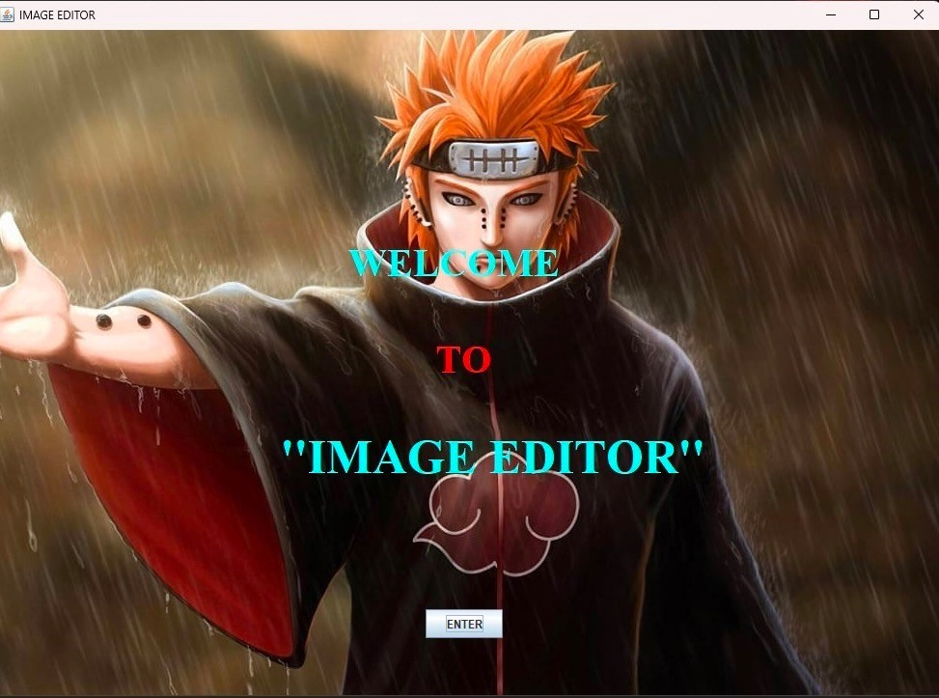

Home Page

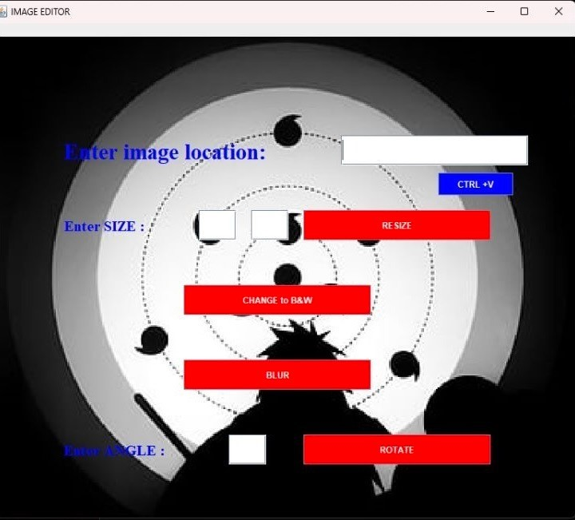

Black and

white

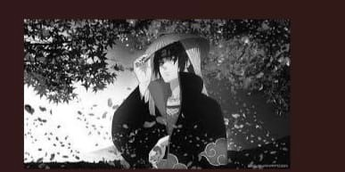

Blur image

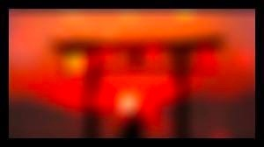

Crop Image

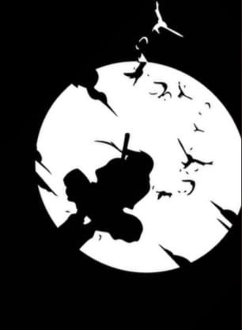

Rotate Image

